Artificial Brain Architecture - Patent Disclosure Document
Confidential - Subject to NDA
Executive Summary
This document describes a novel Artificial Brain Architecture that mimics biological neural learning through a unique combination of:
- Hierarchical Pattern Recognition - Automatically discovers patterns at multiple levels of abstraction
- Temporal Sequence Learning - Learns and predicts time-based sequences and behaviors
- Multi-Modal Integration - Processes multiple types of sensory and motor data simultaneously
- Reward-Based Adaptation - Continuously improves performance based on outcome feedback
- Autonomous Exploration - Discovers new behaviors when existing knowledge is insufficient
The system represents a significant advancement over existing AI approaches by providing a unified architecture that can learn, predict, and act across multiple domains without requiring separate training for each task.
Key Innovations
1. Unified Neural Representation
- Single neuron storage system that handles both sensory inputs and abstract patterns
- Coordinate-based encoding where each neuron represents a point in multi-dimensional space
- Automatic dimension discovery from input channels (vision, audio, motor, financial, etc.)
2. Temporal Connection Architecture
- Directed temporal connections between neurons based on timing relationships
- Distance encoding that captures immediate sequences (distance=1) vs. longer-term patterns (distance=2+)
- Strength-based learning where frequently observed connections become stronger
3. Hierarchical Pattern Discovery
- Automatic pattern detection using peak detection algorithms in connection neighborhoods
- Multi-level abstraction where patterns of patterns form higher-level concepts
- Connection-based patterns that capture relationships rather than just static features
4. Temporal Separation Architecture
- Decision-Action separation where decisions made in frame N are executed in frame N+1
- Prediction validation system that tracks whether predictions come true
- Sliding window memory that maintains context while preventing information overload
5. Channel-Based Integration
- Modular sensory/motor interfaces that can be combined for complex behaviors
- Automatic dimension registration where each channel defines its input/output space
- Unified feedback system where all channels contribute to learning signals
Technical Architecture Overview
The system consists of several key components working together:
Core Database Schema
- Neurons Table: Universal storage for all neural entities
- Coordinates Table: Multi-dimensional position data for each neuron
- Connections Table: Directed temporal relationships between neurons
- Patterns Table: Higher-level abstractions linking pattern neurons to connection signatures
- Active Memory Tables: Sliding window of currently relevant information
Processing Pipeline
- Input Processing: Channels provide multi-dimensional coordinate data
- Recognition: System finds/creates neurons matching input patterns
- Connection Learning: Temporal relationships are reinforced between active neurons
- Pattern Discovery: Peak detection identifies significant connection clusters
- Prediction Generation: System predicts future states based on learned patterns
- Action Execution: Predicted outputs are executed through appropriate channels
- Feedback Integration: Results modify future behavior through reward signals
Learning Mechanisms
- Reinforcement Learning: Successful predictions strengthen associated patterns
- Negative Learning: Failed predictions weaken associated patterns
- Reward Optimization: Performance feedback biases future decision-making
- Forgetting Cycles: Unused patterns decay to prevent overfitting
Competitive Advantages
Versus Traditional Neural Networks
- No pre-training required - learns continuously from experience
- Unified architecture - single system handles multiple modalities
- Explainable decisions - can trace predictions back to learned patterns
- Real-time adaptation - immediately incorporates new information
Versus Reinforcement Learning Systems
- Hierarchical abstraction - automatically discovers high-level strategies
- Multi-modal integration - combines different types of sensors/actuators
- Temporal sequence modeling - naturally handles time-dependent behaviors
- Pattern reuse - learned behaviors transfer to new situations
Versus Expert Systems
- Automatic knowledge acquisition - no manual rule programming required
- Adaptive behavior - continuously improves performance
- Uncertainty handling - gracefully manages incomplete information
- Scalable complexity - handles increasingly sophisticated behaviors
Application Domains
Autonomous Systems
- Robotics: Sensorimotor learning for manipulation and navigation
- Autonomous Vehicles: Multi-sensor fusion for driving decisions
- Drones: Adaptive flight control and mission planning
Financial Systems
- Algorithmic Trading: Pattern recognition in market data
- Risk Management: Multi-factor analysis and prediction
- Portfolio Optimization: Dynamic strategy adaptation
Industrial Control
- Process Optimization: Learning optimal control parameters
- Predictive Maintenance: Pattern recognition in sensor data
- Quality Control: Adaptive inspection and classification
Human-Computer Interaction
- Adaptive Interfaces: Learning user preferences and behaviors
- Natural Language Processing: Context-aware conversation systems
- Personalization: Customizing experiences based on user patterns
Patent Claims Overview
The following aspects represent potentially patentable innovations:
System Architecture Claims
- Unified neural storage system with coordinate-based multi-dimensional representation
- Temporal connection architecture with distance-based relationship encoding
- Hierarchical pattern discovery using connection neighborhood analysis
- Temporal separation mechanism between decision-making and action execution
- Channel-based integration system for multi-modal learning
Method Claims
- Process for automatic pattern discovery in temporal neural networks
- Method for hierarchical abstraction through recursive pattern formation
- Technique for reward-based neural optimization with temporal decay
- Process for autonomous exploration in multi-modal learning systems
- Method for real-time adaptation in continuous learning environments
Application Claims
- System for multi-modal robotic learning combining vision, touch, and motor control
- Method for adaptive financial trading using temporal pattern recognition
- Process for autonomous vehicle control through hierarchical sensorimotor learning
- System for industrial process optimization via continuous pattern adaptation
Implementation Details
Database Architecture
The system uses a MySQL database with both persistent and memory-based tables:
- Persistent tables store learned knowledge (neurons, connections, patterns)
- Memory tables maintain active context (current activations, predictions, inferences)
- Optimized indexing enables real-time processing of large pattern databases
Processing Performance
- Real-time operation suitable for control applications (millisecond response times)
- Scalable architecture that handles increasing complexity gracefully
- Memory efficiency through sliding window and forgetting mechanisms
- Parallel processing capabilities for high-throughput applications
Integration Capabilities
- Modular channel system allows easy addition of new sensor/actuator types
- Standard interfaces for common data types (vision, audio, motor, financial)
- Job-based configuration enables rapid deployment of new applications
- API compatibility with existing systems and frameworks
Visual Architecture Diagrams
The following diagrams illustrate the key architectural concepts:
System Architecture Overview
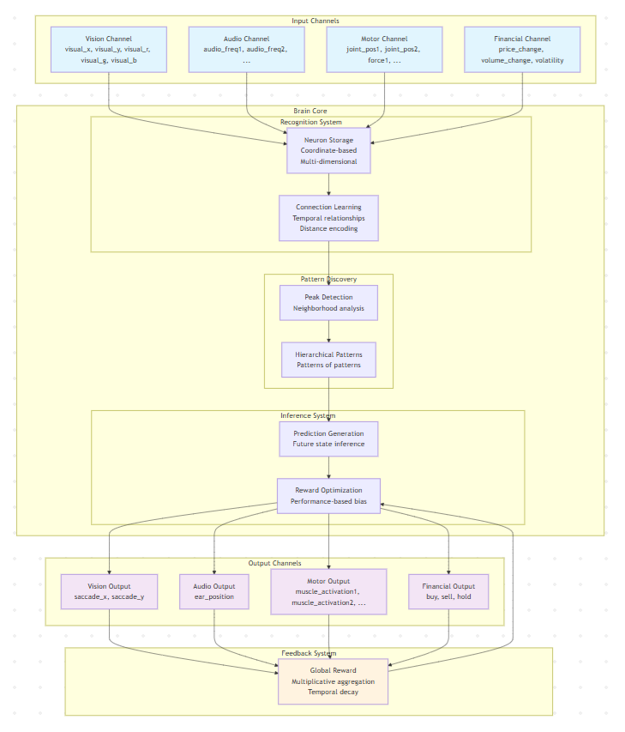
- Shows the complete flow from input channels through brain processing to output channels
- Illustrates the feedback loop that enables continuous learning
- Demonstrates multi-modal integration capabilities
Temporal Connection Learning
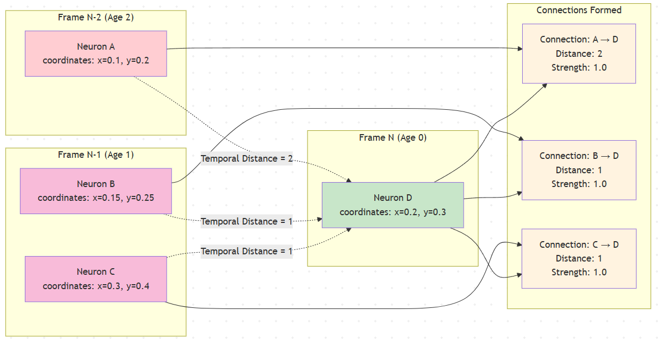
- Shows how neurons form directed connections based on temporal relationships
- Illustrates the distance encoding mechanism (distance=1 for immediate sequences, distance=2+ for longer patterns)
- Demonstrates strength-based learning where repeated observations increase connection strength
Hierarchical Pattern Discovery
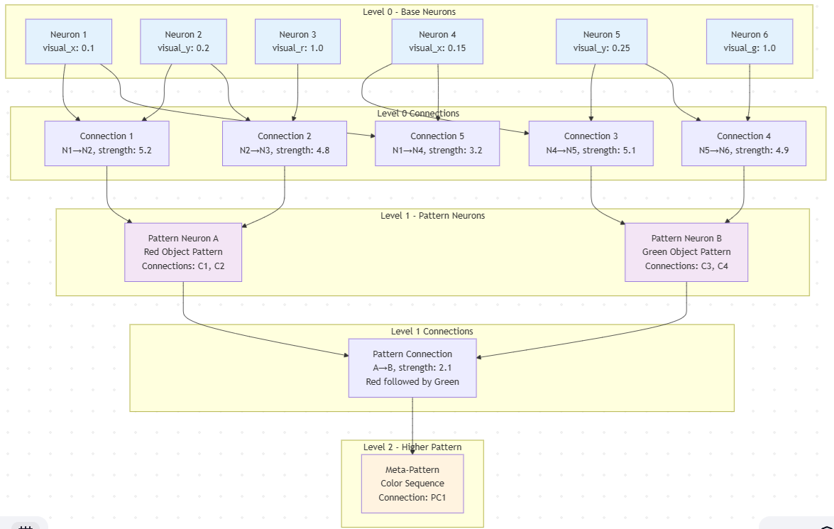
- Shows how base neurons (Level 0) form connections that become patterns (Level 1)
- Illustrates recursive pattern formation where patterns of patterns create higher abstractions (Level 2+)
- Demonstrates the connection-based pattern representation that captures relationships rather than static features
Temporal Separation Architecture
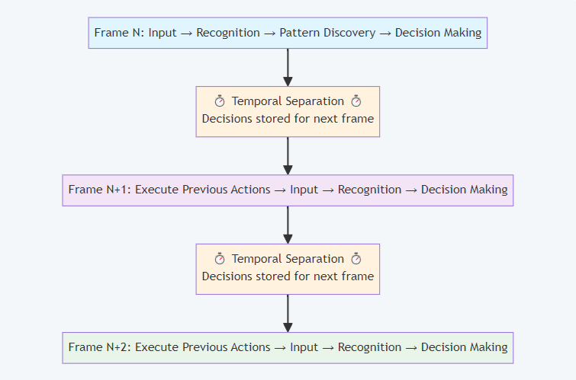
- Shows the critical innovation of separating decision-making from action execution
- Illustrates how decisions made in Frame N are executed in Frame N+1
- Demonstrates the feedback loop where action results inform future decisions
Reward-Based Learning System
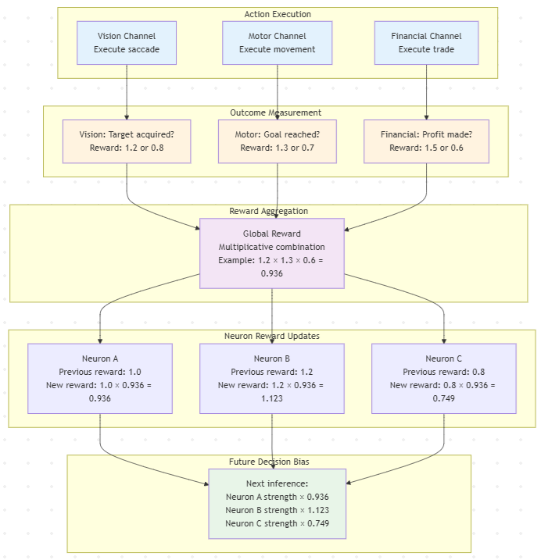
- Shows how multiple channels provide individual reward signals
- Illustrates multiplicative reward aggregation across channels
- Demonstrates how reward factors bias future decision-making through strength optimization
Detailed Technical Innovations
1. Coordinate-Based Neural Representation
Innovation: Unlike traditional neural networks that use abstract weight matrices, this system represents each neuron as a point in multi-dimensional coordinate space.
Technical Details:
- Each neuron has explicit coordinates in named dimensions (e.g., visual_x=0.1, visual_y=0.2, visual_r=1.0)
- Dimensions are automatically registered by channels during system initialization
- Same neuron storage system handles both sensory inputs and abstract pattern representations
- Enables direct mapping between neural activations and real-world coordinate systems
Patent Significance: This coordinate-based approach enables explainable AI where decisions can be traced back to specific coordinate patterns, unlike black-box neural networks.
2. Distance-Encoded Temporal Connections
Innovation: Connections between neurons explicitly encode temporal distance, enabling sophisticated sequence learning.
Technical Details:
- Distance=0: Spatial co-occurrence (simultaneous activation)
- Distance=1: Immediate temporal sequence (A followed by B)
- Distance=2+: Longer-term temporal patterns (A followed by B after delay)
- Connection strength increases with repeated observations
- Higher hierarchical levels use bucketed distances for temporal abstraction
Patent Significance: This distance encoding enables the system to learn and predict sequences at multiple time scales simultaneously, from immediate reactions to long-term behavioral patterns.
3. Peak Detection Pattern Discovery
Innovation: Automatic pattern discovery using neighborhood analysis and peak detection algorithms.
Technical Details:
- Builds bidirectional connectivity graphs from temporal connections
- Calculates neighborhood strength averages for each neuron
- Identifies "peak" neurons whose strength exceeds neighborhood average
- Groups peak connections into pattern signatures
- Matches observed patterns to existing patterns using overlap thresholds (default 66%)
- Creates new pattern neurons for novel connection signatures
Patent Significance: This enables unsupervised learning of hierarchical abstractions without requiring pre-defined pattern templates or training data.
4. Temporal Separation Mechanism
Innovation: Separates decision-making from action execution by one time frame to enable stable learning.
Technical Details:
- Decisions made in frame N (age=0) are stored in inferred_neurons table
- Actions are executed in frame N+1 when neurons reach age=1
- Results of actions inform frame N+1 decision-making
- Prevents feedback loops that could destabilize learning
- Enables prediction validation and reinforcement learning
Patent Significance: This temporal separation solves the stability problem that affects many real-time learning systems, enabling continuous adaptation without oscillation.
5. Multi-Modal Channel Integration
Innovation: Unified architecture that seamlessly integrates multiple sensory and motor modalities.
Technical Details:
- Each channel defines input dimensions (sensors) and output dimensions (actuators)
- Channels automatically register dimensions with brain during initialization
- Single neural representation handles all modalities simultaneously
- Cross-modal pattern discovery enables sensorimotor integration
- Unified reward system aggregates feedback from all channels
Patent Significance: This enables single systems to learn complex behaviors spanning multiple modalities (vision + motor + audio) without requiring separate training for each modality.
Commercial Applications and Market Potential
Robotics Market ($147B by 2025)
- Autonomous manipulation: Learning to grasp and manipulate objects through vision-motor integration
- Navigation systems: Multi-sensor fusion for autonomous movement in complex environments
- Human-robot interaction: Adaptive behavior based on visual, audio, and tactile feedback
Autonomous Vehicles Market ($556B by 2026)
- Sensor fusion: Integration of camera, lidar, radar, and GPS data for driving decisions
- Adaptive control: Learning optimal driving behaviors for different conditions
- Predictive systems: Anticipating traffic patterns and pedestrian behavior
Financial Technology Market ($324B by 2026)
- Algorithmic trading: Multi-factor pattern recognition in market data
- Risk assessment: Temporal pattern analysis for credit and investment decisions
- Fraud detection: Real-time behavioral pattern analysis
Industrial Automation Market ($296B by 2025)
- Process optimization: Learning optimal control parameters through continuous feedback
- Predictive maintenance: Pattern recognition in sensor data to predict equipment failures
- Quality control: Adaptive inspection systems that improve with experience
Conclusion
This Artificial Brain Architecture represents a significant advancement in machine learning and artificial intelligence, providing a unified approach to multi-modal learning, temporal prediction, and adaptive behavior. The system's novel combination of hierarchical pattern recognition, temporal sequence learning, and reward-based adaptation creates new possibilities for autonomous systems across multiple domains.
The architecture's key innovations in neural representation, connection modeling, pattern discovery, and multi-modal integration provide strong foundations for patent protection while offering substantial commercial value across robotics, finance, industrial control, and human-computer interaction applications.
Key Patent Strengths:
- Novel technical approach that differs significantly from existing neural network and AI architectures
- Broad applicability across multiple high-value commercial markets
- Demonstrable technical advantages over current state-of-the-art systems
- Clear implementation pathway with working prototype demonstrating feasibility
- Strong defensive value against competitors in autonomous systems markets

